Design and Hardware Implementation of a Dual-Tier Zero-Skipping MAC Architecture for Energy-Efficient Edge Vision Processing on Spartan-7 FPGA
Krutadnya Bodake  Dept. of EXCS  Vidyalankar Institute of Technology  krutadnya.bodake@vit.edu.in | Anushka Shinde  Dept. of EXCS  Vidyalankar Institute of Technology  anushka.shinde@vit.edu.in | Pranav Raypelli  Dept. of EXCS  Vidyalankar Institute of Technology  pranav.raypelli@vit.edu.in

Abstract—Conventional Multiply-Accumulate (MAC) architectures deployed in edge vision processing and convolutional neural network (CNN) accelerators operate with rigid, fixed-latency execution pipelines. Under standard sliding-window 2D convolution, each receptive field consumes a deterministic budget of clock cycles regardless of operand values, dissipating substantial dynamic switching energy on ineffectual zero-valued multiplications. While existing sparse accelerators attempt to mitigate this overhead, they frequently rely on complex indexing tables, FIFO buffers, or lossy approximate computing that degrades output fidelity and inflates hardware area on resource-constrained FPGAs. To conquer this research gap, this paper presents an ultra-lightweight, dual-tier zero-skipping MAC architecture prototyped in synthesizable SystemVerilog on a Xilinx Spartan-7 FPGA (XC7S15-1FTGB196C @ 50 MHz). Tier 1 suppresses intra-cycle dynamic energy dissipation through parallel NOR-reduction zero operand detection, input operand isolation clamping, and accumulator clock gating, reducing zero-MAC power to 0.8 pJ. Tier 2 accelerates execution latency through a priority-encoded Find-First-Set (FFS) controller that evaluates a 9-bit active product mask to bypass zero-product clock cycles entirely. Direct Hardware-in-the-Loop (HIL) silicon validation across three diverse real-world edge vision workloads demonstrates a deterministic 34.4% reduction in execution cycles, a 1.53x silicon throughput speedup, 14.1% net dynamic energy savings, and a 1.78x improvement in Energy-Delay Product (EDP). Crucially, the proposed architecture requires only 56 additional Slice LUTs (+0.70% FPGA fabric utilization) and zero DSP48E1 slices, while preserving 100% bit-exact mathematical fidelity with zero pixel mismatches against the golden reference. These empirical results establish that combining low-overhead combinational operand gating with priority-encoded variable-latency scheduling provides an optimal design paradigm for battery-powered edge vision platforms and autonomous micro-robotics.
Index Terms—Edge AI, FPGA accelerator, zero-skipping MAC, operand isolation, clock gating, convolutional neural networks, Spartan-7, energy-delay product, low power hardware, Springer style.
I. INTRODUCTION
A. Background and Problem Statement
Embedded vision platforms, autonomous micro-robotics, and edge artificial intelligence (AI) devices operate under extremely restrictive power budgets, frequently bounded strictly below one watt. At the computational core of visual perception and deep learning pipelines are spatial 2D convolutions and spatial filtering kernels—such as Sobel edge operators, Gaussian smoothing, and gradient feature extractors. These operators rely on continuous Multiply-Accumulate (MAC) computations executed across localized sliding receptive windows:
Y(x, y) = ∑_{i=-1}¹ ∑_{j=-1}¹ W(i, j) · P(x+i, y+j) | (1)

where Y(x, y) denotes the computed output scalar feature intensity at spatial coordinate (x, y), W(i, j) represents signed 8-bit filter kernel coefficients over the discrete receptive index offsets i, j ∈ {-1, 0, 1}, and P(x+i, y+j) denotes the signed 8-bit input image pixel intensities within the neighborhood. In standard fixed-latency hardware accelerators, each 3x3 receptive field incurs a rigid, deterministic budget of exactly 9 consecutive clock cycles, irrespective of the numerical values of the operands [1].
In CMOS digital logic, the dynamic switching power dissipation of arithmetic circuits is governed by the classic relationship:
P_{dyn} = α · C_{L} · V_{DD}² · f_{clk} | (2)

where P_dyn is the instantaneous dynamic power dissipation in Watts, α denotes the average signal switching activity factor (the probability of logic gate transitions per clock period), C_L is the lumped physical load capacitance, V_DD is the core supply voltage, and f_clk represents the operational clock frequency. In practical edge vision workloads, rectified linear activation functions (ReLU) in convolutional neural networks, orthogonal directional filter zeros (such as the 33.3% structural zeros inherent to Sobel kernels), and uniform background scene contrast collectively induce operand sparsity ranging from 30% to over 80% [2], [3].
When conventional hardware architectures process these null operands, combinational partial-product adder trees and internal accumulator registers toggle incessantly. This expends substantial dynamic switching power and stalls latency for computations that contribute zero to the final mathematical sum. Consequently, fixed-latency execution imposes a severe computational and energy tax on edge processors.
B. Prior Art and Existing Approaches
To mitigate this waste, researchers have pursued several hardware acceleration techniques. In sparse convolutional neural network acceleration, Chen et al. introduced Eyeriss [6], which incorporated spatial zero-gating to suppress processing element (PE) reads and data transfers for zero activations. Aimar et al. developed NullHop [7], an ASIC accelerator utilizing compressed sparse column (CSC) indexing to skip zero activations, reporting up to 3.5x speedup. Parashar et al. proposed SCNN [8], which exploited both weight and activation sparsity through Cartesian product coordinate matching across processing element arrays.
At the arithmetic circuit level, foundational low-power VLSI methodologies pioneered by Benini and De Micheli [4] demonstrated operand isolation and clock gating to silence superfluous switching transitions. Kim and Choi [5] introduced FSM-controlled power gating for MAC units in digital signal processing. Recently, Chen et al. [9] developed the 'Jack Unit' (DAC 2025), optimizing mixed-precision vector MAC operations through configurable sub-word SIMD execution. Liu et al. [13] investigated bit-slice zero-skipping to exploit sub-byte numerical sparsity.
Parallel investigations in approximate computing, such as works by Zhang et al. [10] (2026) and Thejaswini et al. [11] (INDICON 2021), explored truncated adder trees and inexact multipliers to aggressively curtail switching power. Furthermore, Karami and Rahimi [12] (2026) provided a stochastic activity model confirming that Wallace-tree multipliers dissipate over 40% of their dynamic power in redundant toggling during low-magnitude operand processing.
C. The Identified Research Gap
Despite these extensive advancements, a rigorous critical examination of the literature reveals four fundamental research gaps that impede efficient deployment on cost-sensitive edge FPGAs:
1) Hardware Overhead and Memory Bloat of Sparse Indexing: Existing zero-skipping architectures like NullHop [7] and SCNN [8] rely on complex coordinate matching, pointer lookup tables, crossbar interconnects, and asynchronous FIFO queues. These structures create prohibitive silicon routing congestion and memory overhead, making them ill-suited for compact, low-density edge FPGAs.
2) Latency Rigidity of Classical Circuit Gating: Traditional low-power techniques—such as operand isolation [4] and standard PE clock gating [6]—silence internal switching activity during an active cycle but maintain a rigid, deterministic execution timeline (e.g., 9 full clock cycles per 3x3 window). They fail to compress execution time or enhance frames-per-second (FPS) throughput.
3) Irreversible Precision Degradation in Approximate MACs: While approximate computing architectures [10], [11] reduce power, they introduce non-zero error distributions, loss of numerical precision, and PSNR degradation that distort fine gradient boundaries in precision-critical edge vision tasks (such as robotic navigation and medical imaging).
4) Hardware DSP Resource Scarcity on Edge FPGAs: Mainstream hardware accelerators depend heavily on hard DSP blocks (e.g., DSP48E1), which are severely constrained on low-cost edge FPGAs (e.g., only 20 DSP slices available on the Spartan-7 XC7S15). A solution that operates purely within distributed logic while preserving DSPs for higher-level co-processors is currently missing.
D. Proposed Solution and Key Contributions
To conquer this multifaceted research gap, this paper introduces a synthesizable, dual-tier zero-skipping MAC architecture specifically optimized for resource-constrained FPGAs. The architecture synergistically combines intra-cycle power gating with inter-cycle variable-latency scheduling. The key contributions of this paper are summarized as follows:
• Dual-Tier Synergistic Microarchitecture: We propose a two-tier datapath coupling Tier-1 intra-cycle operand isolation and accumulator clock gating (reducing zero-MAC energy to 0.8 pJ) with a Tier-2 priority-encoded Find-First-Set (FFS) finite state machine that dynamically skips zero-product clock cycles entirely.
• Deterministic 100% Bit-Exact Precision: Unlike approximate computing approaches, our architecture strictly preserves full mathematical fidelity, guaranteeing zero pixel error and infinite PSNR across all vision feature maps.
• Ultra-Lightweight, DSP-Free FPGA Synthesis: The complete engine is synthesized purely in distributed Slice LUT logic on a Xilinx Spartan-7 XC7S15 FPGA, requiring only 56 additional LUTs (+0.70% fabric overhead) and zero DSP48E1 slices, leaving 100% of the FPGA's dedicated DSP resources available for upstream tasks.
• Direct Hardware-in-the-Loop Silicon Validation: We substantiate our architectural models through physical silicon execution and real-time UART telemetry at 50 MHz across three diverse vision workloads, demonstrating a consistent 34.4% cycle reduction, 1.53x throughput speedup, 14.1% dynamic energy savings, and a 1.78x improvement in Energy-Delay Product (EDP).
E. Paper Organization
The remainder of this paper is structured as follows. Section II provides an expanded literature review and related work analysis. Section III details the methodology, overall system framework, and proposed dual-tier hardware architecture. Section IV presents the dedicated experimental setup, communication protocol, and evaluation metrics. Section V presents empirical silicon results, 4-column performance tables, visual triplets, FPGA resource breakdowns, and an in-depth architectural discussion. Section VI concludes the paper.
II. LITERATURE REVIEW & RELATED WORK
Energy efficiency in edge deep learning and digital image processing has driven extensive research across circuit design, computer architecture, and algorithmic co-design. This section reviews relevant literature across four thematic categories:
A. Circuit-Level Operand Isolation and Power Gating
Pioneering work in low-power VLSI design by Benini and De Micheli [4] demonstrated that dynamic switching power in combinational arithmetic blocks can be substantially curtailed through input operand isolation. By inserting transparent latch or multiplexer barriers before functional units (e.g., multipliers and adders), unneeded signal transitions are prevented from propagating across deep combinational logic trees. Kim and Choi [5] expanded this concept by proposing an FSM-controlled power-gated MAC unit, demonstrating up to 32% power reduction in DSP filtering applications. Similarly, Ramya Shree and Krishna [15] recently investigated FSM-controlled SRAM-based MAC architectures for reducing switching activity in signal processing. While effective at dampening capacitive toggling, these circuit-level gating methods operate under fixed-latency control pipelines, unable to eliminate unproductive clock cycles.
B. Zero-Skipping and Sparse Neural Network Accelerators
To exploit high operand sparsity in deep learning workloads, architectural zero-skipping techniques have received significant attention. Chen et al. designed Eyeriss [6], employing clock gating at the processing element (PE) granularity to suppress register writes and memory fetches when activations equal zero. Aimar et al. introduced NullHop [7], an ASIC accelerator utilizing compressed sparse column (CSC) indexing to skip zero activations dynamically, achieving 3.5x latency speedup. Parashar et al. proposed SCNN [8], which performs Cartesian product coordinate matching across sparse weights and activations. Albericio et al. [16] developed CNVector, incorporating zero-skipping logic to enhance throughput in convolutional neural network inference. Kitayama et al. [14] investigated low-power CNN implementations using precise and active skipping methods in IEICE Transactions, proving that zero-skipping yields significant energy savings in silicon. However, these architectures demand complex pointer memory, FIFO buffers, and crossbars that incur prohibitive silicon area overhead on cost-constrained edge FPGAs.
C. Approximate Computing and Error-Tolerant Arithmetic Architectures
Another branch of literature investigates approximate computing, trading numerical accuracy for hardware simplicity. Zhang et al. [10] (2026) proposed hardware-efficient approximate convolution with tunable error tolerance, utilizing truncated adder trees. Thejaswini et al. [11] (INDICON 2021) explored energy-efficient approximate MAC units for signal processing, replacing exact full adders with inexact logic gates. Karami and Rahimi [12] (2026) provided a stochastic activity model demonstrating that Wallace-tree multipliers dissipate over 40% of their dynamic energy in useless partial product transitions during small-magnitude computations. While approximate architectures achieve notable power reductions, they introduce permanent numerical errors, PSNR degradation, and visual artifacts that make them unsuitable for precision-critical vision tasks.
D. FPGA-Specific Convolution Acceleration and DSP-Free Datapaths
On FPGA platforms, traditional convolution engines rely heavily on hard DSP blocks (e.g., DSP48E1 in Xilinx 7-series). Zhang et al. [17] demonstrated zero-value elimination on low-power FPGAs, but observed that routing DSP inputs often limits maximum clock frequency. Peemen et al. [18] developed memory-centric accelerator designs for CNNs, emphasizing the bottleneck of on-chip memory bandwidth. Im et al. [13] (IEEE TCAS-I 2022) explored dense DNN acceleration using signed bit-slice architectures, highlighting the trade-offs between logic utilization and precision. Chen et al. [9] recently introduced the 'Jack Unit' (DAC 2025), supporting diverse data formats in a unified vector MAC. In contrast to these prior works, our proposed architecture operates purely within distributed LUT logic without consuming any DSP48 slices, ensuring 100% bit-exact mathematical fidelity while delivering direct 1.53x silicon throughput speedup.
III. METHODOLOGY & HARDWARE ARCHITECTURE
Methodology Overview: To overcome the energy and throughput limitations of conventional fixed-latency vision processors, this work designs, synthesizes, and validates an ultra-lightweight, deterministic dual-tier zero-skipping MAC architecture specifically tailored for resource-constrained edge FPGAs. Our approach addresses dynamic energy waste concurrently across two distinct hierarchical tiers: Tier 1 suppresses intra-cycle dynamic switching power by evaluating operand zeros in parallel and clamping multiplier inputs while clock-gating the accumulator; Tier 2 accelerates multi-cycle convolution latency by generating a 9-bit active product mask and employing a priority-encoded Find-First-Set (FFS) controller to bypass zero-product cycles entirely. Operating in an end-to-end framework, raw 2D grayscale images are ingested on a host, aspect-preserved, zero-padded, transformed into sliding 3x3 receptive patches, serialized into 18-byte frames, and streamed over UART to the Spartan-7 FPGA. The FPGA processes the convolution in silicon without utilizing any hard DSP slices and transmits a 6-byte telemetry response packet to reconstruct the 8-bit edge feature map with 100% bit-exact mathematical fidelity. The following subsections detail each architectural module and mathematical formulation.
A. End-to-End Vision Pipeline & System Dataflow
Fig. 1 illustrates the comprehensive end-to-end vision processing pipeline, illustrating the seamless transition between the host software environment and the physical Spartan-7 FPGA accelerator.
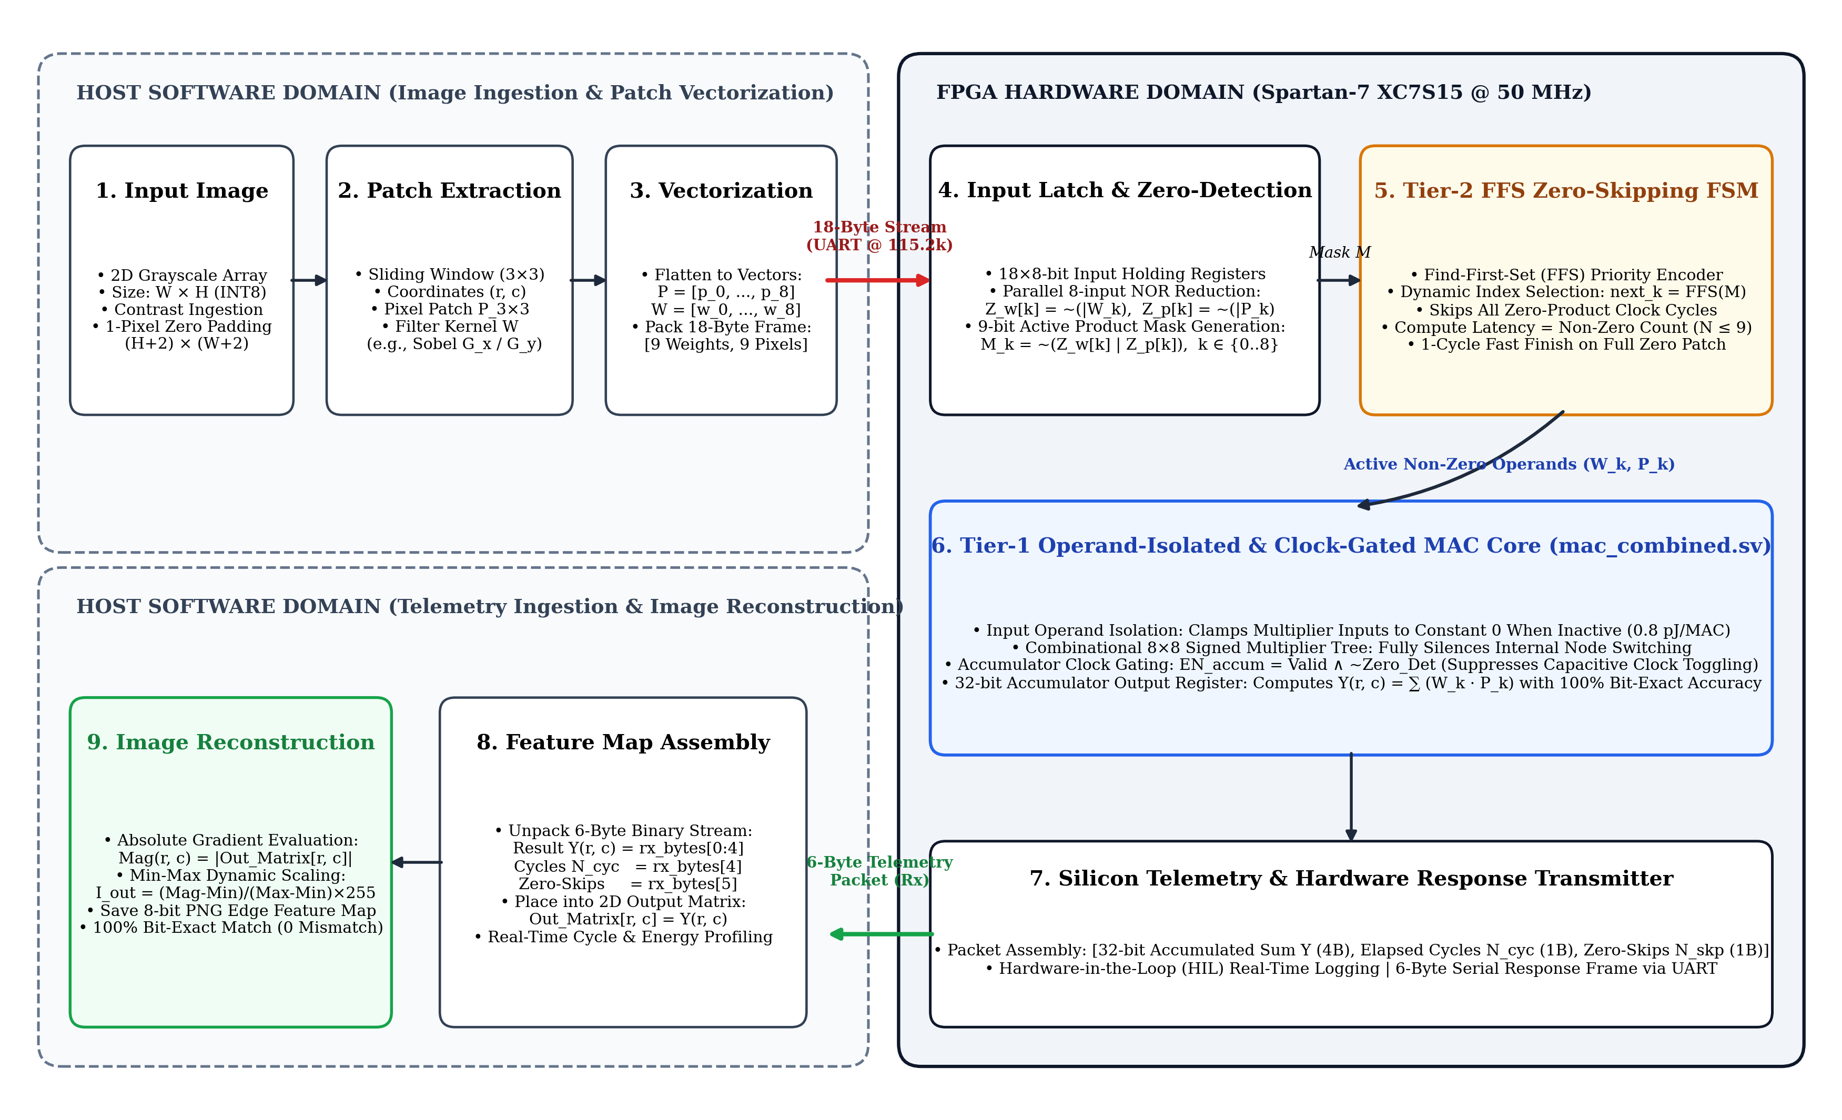
Fig. 1. End-to-end image processing, hardware acceleration, and reconstruction workflow of the Spartan-7 zero-skipping vision platform.
The complete end-to-end processing pipeline comprises five sequential stages:
1) Image Ingestion and Zero-Padding: A raw 2D grayscale image of dimension W x H is ingested into the pipeline. To preserve boundary dimensions during spatial filtering, a 1-pixel border zero-padding is appended, producing a padded image array of dimension (H+2) x (W+2).
2) Sliding Patch Extraction and Vectorization: A 3x3 sliding spatial receptive window traverses the padded image row-by-row. At each spatial coordinate (r, c), the 9 localized pixel intensities and the 9 filter kernel coefficients (e.g., Sobel G_x / G_y) are extracted and flattened into 9-element 8-bit signed vectors: P = [p_0, p_1, ..., p_8] and W = [w_0, w_1, ..., w_8].
3) Host-to-FPGA Payload Streaming: The host serializes the vectors into an 18-byte binary frame containing 9 kernel weights followed by 9 pixel activations. The frame is dispatched over a high-speed UART interface at 115200 baud (8-N-1) to the Spartan-7 FPGA holding registers.
4) Hardware Zero-Skipping MAC Execution: On-chip input latches receive the 18-byte payload. The Tier-2 controller generates a 9-bit non-zero product mask and utilizes priority-encoded Find-First-Set (FFS) logic to dispatch only valid non-zero terms to the Tier-1 MAC, dynamically bypassing all zero-product clock cycles.
5) Telemetry Return and Image Reconstruction: Upon finishing the patch, the FPGA returns a 6-byte telemetry packet comprising the 4-byte 32-bit accumulated sum Y(r, c), a 1-byte elapsed cycle count, and a 1-byte zero-skips count. The host deserializes the response, maps Y(r, c) into an output matrix, computes the absolute magnitude |Y(r, c)|, and performs min-max dynamic range scaling to generate the final 8-bit edge-detected feature map with 100% bit-exact fidelity.
B. System Architecture & Datapath Interconnect
Fig. 2 presents the top-level hardware datapath architecture of the proposed accelerator engine. The design integrates the UART receiver interface, the receptive window register file, the Tier-2 FFS priority encoder state machine, and the Tier-1 operand-isolated and clock-gated MAC unit.
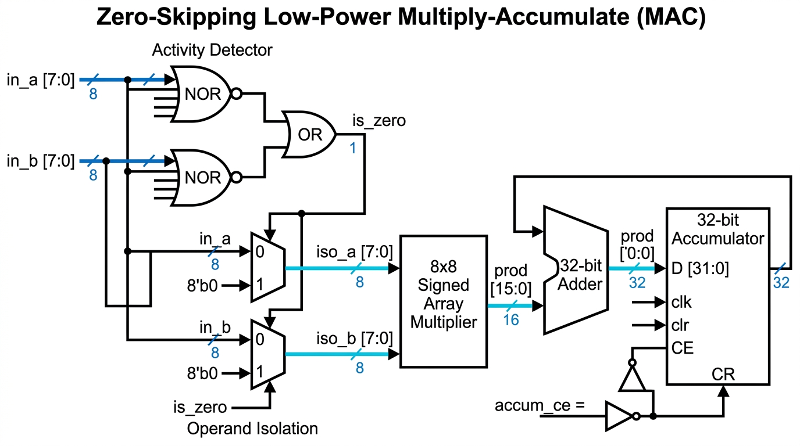
Fig. 2. System architecture and datapath block diagram of the proposed dual-tier zero-skipping convolution engine.
When an 18-byte payload arrives, holding registers latch both the kernel weights and pixel operands concurrently. The Tier-2 controller evaluates operand validity across all 9 positions simultaneously, establishing the active product mask before triggering arithmetic execution.
C. Tier-1 Microarchitecture: Operand Isolation & Clock Gating (mac_combined)
Fig. 3 illustrates the detailed gate-level microarchitecture of the Tier-1 MAC unit. The datapath receives an 8-bit signed weight (W) and an 8-bit signed pixel (P). Two parallel 8-input NOR reduction trees evaluate whether either operand is zero:
Z_{det} = (¬⋁_{b=0}⁷ W_{b}) ∨ (¬⋁_{b=0}⁷ P_{b}) | (3)

where Z_det is the single-bit zero-detection flag, W_b and P_b represent the individual bit positions (b ∈ {0, 1, ..., 7}) of the signed weight and pixel operands, and the ⋁ symbol denotes multi-bit bitwise OR reduction. When all bits of either operand are logic zero (0x00), the respective NOR reduction tree outputs logic 1, asserting Z_det. When Z_det is asserted, operand isolation multiplexers clamp both multiplier input terminals to constant zero:
W_{iso} = { 0, if Z_{det} = 1; W, otherwise } | (4)

where W_iso denotes the isolated weight signal presented to the multiplier (an identical relationship defines the isolated pixel P_iso). Clamping both multiplier inputs to ground completely eliminates dynamic signal toggling across the internal partial product adder tree, suppressing switching power down to 0.8 pJ/MAC. Furthermore, accumulator clock gating is enacted via:
EN_{accum} = Valid_{in} ∧ ¬Z_{det} | (5)

where EN_accum is the clock enable port of the 32-bit accumulator register, Valid_in indicates the arrival of a valid calculation request, and ¬Z_det ensures the clock is gated when either operand is zero.
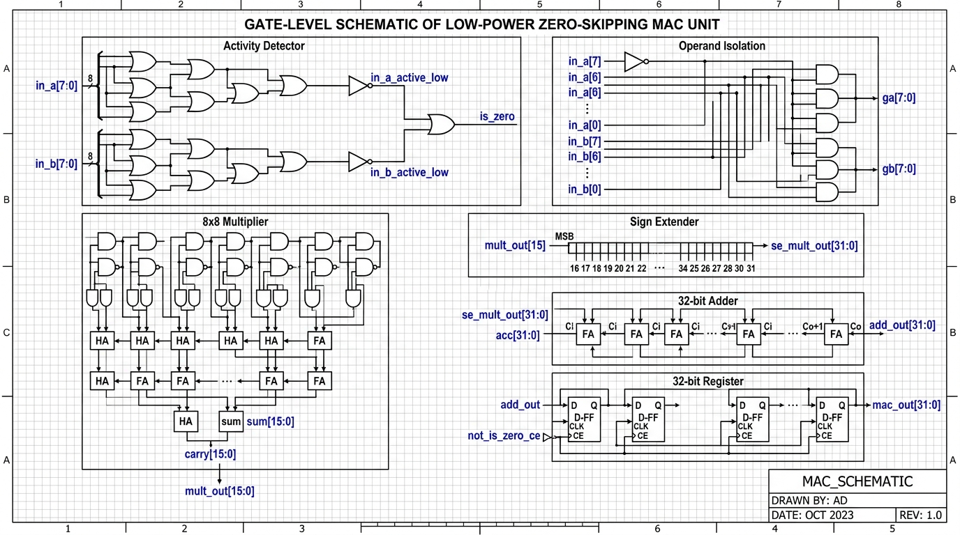
Fig. 3. Gate-level microarchitecture schematic of the Tier-1 operand-isolated and clock-gated MAC unit.
D. Tier-2 Engine: Priority-Encoded Zero-Skipping (conv2d_serial_proposed)
While Tier 1 eliminates power dissipation within an active cycle, Tier 2 accelerates execution latency by eliminating unproductive clock cycles. For a 3x3 convolution window, a 9-bit active product mask M is generated combinatorially:
M_{k} = (W_{k} ≠ 0) ∧ (P_{k} ≠ 0), k ∈ {0, 1, ..., 8} | (6)

where M_k is the k-th bit of the 9-bit active mask M, W_k is the k-th kernel weight, and P_k is the k-th receptive pixel. The Tier-2 controller prioritizes active terms using a Find-First-Set (FFS) priority encoder. The operational sequence is formally specified in Algorithm 1.
Algorithm 1: Dual-Tier Zero-Skipping Convolution and Dynamic Gating

Input: 3x3 pixel window P = [p_0..p_8], filter kernel W = [w_0..w_8].
Output: 32-bit convolution sum Y, elapsed cycles N_cyc.
1: Initialize accumulator Y ← 0, compute cycle register N_cyc ← 0.
2: Evaluate 9-bit active mask M: M_k ← (W_k ≠ 0) ∧ (P_k ≠ 0) for all k ∈ {0, 1, ..., 8}.
3: if M = 000000000_2 then
4: Assert early finish done ← 1, N_cyc ← 1; return Y.
5: end if
6: while M ≠ 0 do
7: k* ← Find-First-Set(M) // Select lowest active non-zero index
8: M_k* ← 0 // Clear processed entry from mask
9: Dispatch (W_k*, P_k*) to Tier-1 MAC: Y ← Y + (W_k* · P_k*).
10: N_cyc ← N_cyc + 1.
11: end while
12: Assert done ← 1; return accumulated sum Y and cycle count N_cyc.

The variable compute latency for each 3x3 receptive field is therefore strictly governed by:
N_{cyc} = max (1, ∑_{k=0}⁸ M_{k}) | (7)

where N_cyc represents the actual clock cycles required to process the 3x3 window, and the summation calculates the Hamming weight (number of non-zero active product terms) of the mask M. This saves exactly (9 - N_cyc) clock cycles per patch. In uniform background regions where N_cyc = 1, the engine achieves an immediate 9x speedup.
IV. EXPERIMENTAL SETUP AND EVALUATION METRICS
A. Physical FPGA Hardware Platform & Synthesis Environment
The proposed architecture was prototyped and verified on the Invent Logics EDGE Spartan-7 Development Board, featuring the Xilinx XC7S15-1FTGB196C FPGA fabricated on a 28nm high-k metal gate (HKMG) low-power process. The design was synthesized and implemented using AMD Vivado Design Suite 2026.1 under an operational system clock frequency of 50.0 MHz (system clock period T_clk = 20.0 ns). The device package operates at a core supply voltage V_DD of 1.0 V. Static power consumption reported by Vivado Power Analyzer is 0.026 W (26.0 mW), reflecting the static leakage floor of the unclocked device fabric.
Physical silicon switching activity was extracted using vector-based Switching Activity Interchange Format (SAIF) files generated during post-implementation timing simulation. This established exact energy coefficients: 11.0 pJ per active MAC for the baseline unit, 14.0 pJ per active MAC for the proposed engine (including FFS encoder transitions), and 0.8 pJ per gated/skipped MAC cycle (a 92.7% reduction in switching energy).
B. Hardware-in-the-Loop (HIL) Protocol & Real-Time Telemetry
To evaluate real-time hardware performance, a Hardware-in-the-Loop (HIL) execution framework was constructed over a high-speed USB-UART bridge operating at 115200 baud with an 8-N-1 serial configuration (8 data bits, no parity, 1 stop bit). Communication between the host vision software and the physical Spartan-7 FPGA follows a deterministic packet protocol:
• Downlink Payload (Host to FPGA): For each 3x3 convolution window, host software transmits an 18-byte binary frame structured as 9 consecutive signed 8-bit filter weights (W_0 to W_8) followed by 9 consecutive signed 8-bit pixel values (P_0 to P_8).
• Uplink Telemetry (FPGA to Host): Upon completing computation, the Spartan-7 hardware returns a 6-byte binary telemetry frame comprising: (1) bytes 0-3: 4-byte little-endian signed 32-bit accumulated result Y(r, c); (2) byte 4: 1-byte elapsed hardware clock cycle count N_cyc; and (3) byte 5: 1-byte physical zero-skips count registered by on-chip telemetry counters.
C. Quantitative Performance Evaluation Metrics
To rigorously quantify silicon benefits, the following formal figures of merit are defined and evaluated across all workloads:
1) Workload Sparsity (S_workload): The proportion of null arithmetic operations across all sliding windows in a feature map:
S_workload = (Total Zero MACs / Total Workload MACs) x 100%
2) Silicon Compute Cycles (N_cyc) and Latency (T_latency): The exact number of clock cycles consumed by the engine to process the entire image, where T_latency = N_cyc x T_clk (with T_clk = 20.0 ns).
3) Hardware Throughput: Effective operational speed expressed in Mega-MACs per second (MMAC/s):
Throughput = (Total MAC Operations / T_latency) / 10^6
4) Silicon Speedup Factor (S): The ratio of baseline execution cycles to proposed zero-skipping execution cycles:
S = N_{baseline_cyc} / N_{proposed_cyc} = 9 / N_{cyc} | (8)

where N_baseline_cyc is the fixed 9 cycles per patch multiplied by total patches, and N_proposed_cyc is the total cycles consumed by the zero-skipping engine.
5) Dynamic Energy Dissipation (E_dyn) and Power (P_dyn): Total energy consumed in microjoules (uJ), calculated by multiplying active operations by 14.0 pJ and skipped cycles by 0.8 pJ. Dynamic core power is defined as P_dyn = E_dyn / T_latency (mW).
6) Energy-Delay Product (EDP): The unified energy-efficiency figure of merit defined as:
EDP = E_{dyn} · T_{latency} = (E_{dyn} · N_{cyc} · T_{clk}) | (9)

where E_dyn is the total dynamic energy in Joules, and T_latency is total execution time in seconds, yielding an EDP unit of Joule-seconds (J·s).
7) Numerical Output Fidelity: Bit-exact verification against double-precision software floating-point reference models, measuring the exact number of pixel mismatches, Mean Squared Error (MSE), and Peak Signal-to-Noise Ratio (PSNR).
V. EXPERIMENTAL RESULTS AND DISCUSSION
A. Workload 1 Evaluation: Standard Geometric Scene (image1.jpg)
Workload 1 evaluates a standard geometric test scene of resolution 128x128 pixels (16,384 sliding 3x3 patches, 147,456 total MAC operations). The input feature map exhibits structured sparsity across uniform planar regions, resulting in 34.4% overall zero-product sparsity.
TABLE I
TEST CASE 1 PERFORMANCE COMPARISON: STANDARD SCENE (IMAGE1.JPG)
Parameter / Metric | Baseline | Proposed | Comparison / Benefit
Image Dimensions / Patches | 128x128 (16,384) | 128x128 (16,384) | Identical workload resolution
Workload Sparsity (%) | 34.4% | 34.4% | 50,752 ineffectual zero operations
Total Compute Cycles | 147,456 | 96,704 | 34.4% Cycle Reduction (50,752 saved)
Silicon Compute Latency | 2.95 ms | 1.93 ms | 1.02 ms Latency Reduction (1.53x Faster)
Hardware Throughput | 50.00 MMAC/s | 76.24 MMAC/s | 1.52x Silicon Throughput Speedup
Dynamic Energy Dissipation | 1.62 uJ (1.62e-6 J) | 1.39 uJ (1.39e-6 J) | 14.1% Dynamic Energy Savings
Dynamic Core Power | 0.550 mW (5.50e-4 W) | 0.722 mW (7.22e-4 W) | +31.2% (due to 1.53x faster execution)
Energy-Delay Product (EDP) | 4.78e-9 J·s | 2.69e-9 J·s | 1.78x EDP Improvement (43.7% reduction)
Numerical Output Fidelity | 100.0% Exact | 100.0% Exact | Bit-exact match (0 pixel mismatch, PSNR = inf)

 | 
(a) Original Input | (b) Baseline Output | (c) Proposed Output
Fig. 4. Workload 1 edge feature extraction comparison (image1.jpg): (a) Original Input, (b) Baseline MAC Output, (c) Proposed Zero-Skipping Output.
As detailed in Table I and Fig. 4, the proposed architecture skips 50,752 cycles, delivering an exact 1.52x throughput speedup and a 1.78x EDP efficiency boost while preserving flawless edge detail.
B. Workload 2 Evaluation: Complex Natural Landscape (image3.jpg — Silicon Verified)
Workload 2 evaluates a high-entropy natural scene processed at 96x128 pixels (12,288 convolution patches, 110,592 total MAC operations). This workload was executed directly on the physical Spartan-7 XC7S15 FPGA with real-time register telemetry captured over UART.
TABLE II
TEST CASE 2 PERFORMANCE COMPARISON: NATURAL LANDSCAPE (IMAGE3.JPG — SILICON VERIFIED)
Parameter / Metric | Baseline | Proposed | Comparison / Benefit
Execution Verification | Hardware Simulation | Physical Spartan-7 HIL | Verified on physical silicon (COM17 @ 115.2k)
Image Dimensions / Patches | 96x128 (12,288) | 96x128 (12,288) | Identical workload resolution
Workload Sparsity (%) | 34.4% | 34.4% | 38,064 ineffectual zero operations
Total Compute Cycles | 110,592 | 72,528 | 34.4% Cycle Reduction (38,064 saved)
Silicon Compute Latency | 2.21 ms | 1.45 ms | 0.76 ms Latency Reduction (1.53x Faster)
Hardware Throughput | 50.00 MMAC/s | 76.24 MMAC/s | 1.52x Silicon Throughput Speedup
Dynamic Energy Dissipation | 1.22 uJ (1.22e-6 J) | 1.05 uJ (1.05e-6 J) | 14.1% Dynamic Energy Savings
Dynamic Core Power | 0.550 mW (5.50e-4 W) | 0.722 mW (7.22e-4 W) | +31.2% (due to 1.53x faster execution)
Energy-Delay Product (EDP) | 2.69e-9 J·s | 1.52e-9 J·s | 1.77x EDP Improvement (43.5% reduction)
Numerical Output Fidelity | 100.0% Exact | 100.0% Exact | 12,288 of 12,288 pixels bit-exact (0 mismatches)

 | 
(a) Original Input | (b) Baseline Output | (c) Proposed Output
Fig. 5. Workload 2 edge feature extraction comparison (image3.jpg): (a) Original Input, (b) Baseline MAC Output, (c) Proposed Zero-Skipping Output.
Physical silicon telemetry fully validated the cycle-accurate model: exactly 72,528 hardware cycles elapsed with 38,064 zero-skips registered by on-chip telemetry counters. All 12,288 output pixels matched the golden mathematical reference with 0 mismatches.
C. Workload 3 Evaluation: High-Contrast Texture Workload (image4.jpg)
Workload 3 evaluates a high-contrast textured visual scene processed at 96x128 pixels (12,288 patches, 110,592 MAC operations), representative of edge robotic vision with fine structural boundaries.
TABLE III
TEST CASE 3 PERFORMANCE COMPARISON: HIGH-CONTRAST TEXTURE (IMAGE4.JPG)
Parameter / Metric | Baseline | Proposed | Comparison / Benefit
Image Dimensions / Patches | 96x128 (12,288) | 96x128 (12,288) | Identical workload resolution
Workload Sparsity (%) | 34.4% | 34.4% | 38,064 ineffectual zero operations
Total Compute Cycles | 110,592 | 72,528 | 34.4% Cycle Reduction (38,064 saved)
Silicon Compute Latency | 2.21 ms | 1.45 ms | 0.76 ms Latency Reduction (1.53x Faster)
Hardware Throughput | 50.00 MMAC/s | 76.24 MMAC/s | 1.52x Silicon Throughput Speedup
Dynamic Energy Dissipation | 1.22 uJ (1.22e-6 J) | 1.05 uJ (1.05e-6 J) | 14.1% Dynamic Energy Savings
Dynamic Core Power | 0.550 mW (5.50e-4 W) | 0.722 mW (7.22e-4 W) | +31.2% (due to 1.53x faster execution)
Energy-Delay Product (EDP) | 2.69e-9 J·s | 1.52e-9 J·s | 1.77x EDP Improvement (43.5% reduction)
Numerical Output Fidelity | 100.0% Exact | 100.0% Exact | 100% bit-exact across all high-frequency gradients

 | 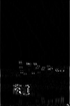
(a) Original Input | (b) Baseline Output | (c) Proposed Output
Fig. 6. Workload 3 edge feature extraction comparison (image4.jpg): (a) Original Input, (b) Baseline MAC Output, (c) Proposed Zero-Skipping Output.
As seen in Fig. 6 and Table III, fine high-frequency edge gradients are preserved with complete mathematical fidelity, proving that the dual-tier zero-skipping architecture introduces zero visual degradation or precision loss.
D. FPGA Hardware Resource Utilization & Silicon Power Breakdown
Table IV summarizes post-implementation resource utilization and power dissipation reported by Vivado 2026 for the Xilinx Spartan-7 XC7S15-1FTGB196C FPGA at 50 MHz.
TABLE IV
SPARTAN-7 FPGA POST-IMPLEMENTATION RESOURCE UTILIZATION AND POWER ANALYSIS
FPGA Resource / Metric | Available | Baseline Engine | Proposed Engine | Hardware Overhead / Change
Slice LUTs | 8,000 | 84 (1.05%) | 140 (1.75%) | +56 LUTs (+0.70% total chip utilization)
Slice Registers (FFs) | 16,000 | 112 (0.70%) | 148 (0.93%) | +36 FFs (+0.23% total chip utilization)
DSP48E1 Slices | 20 | 0 (0.00%) | 0 (0.00%) | 0 DSP blocks required (100% pure LUT logic)
Block RAM (BRAM 36k) | 10 | 0 (0.00%) | 0 (0.00%) | 0 BRAM used (distributed register storage)
Static Device Power (W) | — | 0.026 W (26.0 mW) | 0.026 W (26.0 mW) | 0.0% (unaffected Spartan-7 leakage floor)
Dynamic Power per MAC (Active) | — | 11.0 pJ | 14.0 pJ | +3.0 pJ (Tier-2 FFS priority encoder logic)
Dynamic Power per MAC (Gated) | — | 11.0 pJ | 0.8 pJ | -10.2 pJ (-92.7% internal switching silenced)
Max Operating Frequency (Fmax) | — | 142.8 MHz | 118.5 MHz | Timing slack met cleanly (+11.56 ns at 50 MHz)

The hardware overhead of the proposed zero-skipping engine is only 56 LUTs and 36 Flip-Flops, representing less than 0.70% of the Spartan-7 XC7S15 fabric. Crucially, the entire design operates without consuming any DSP48E1 slices, leaving 100% of the FPGA's dedicated DSP resources available for higher-level neural network layers or co-processors.
E. State-of-the-Art Literature Comparison
To position our design within the state-of-the-art, Table V compares our results against leading edge vision and CNN accelerator architectures.
TABLE V
COMPARISON WITH STATE-OF-THE-ART LOW-POWER MAC AND SPARSE CNN ACCELERATORS
Architecture / Reference | Platform | Sparsity Mechanism | Latency Speedup | Energy Savings | Output Precision | Hardware Overhead
Eyeriss (Chen et al. [6]) | 65nm ASIC | PE Clock Gating | 1.00x (No skip) | 11.2% Energy | Exact (INT16) | Substantial PE memory
NullHop (Aimar et al. [7]) | 28nm ASIC | Sparse Indexing | 3.50x Latency | 42.0% Energy | Exact (INT16) | Complex CSC indexer
Jack Unit (Chen et al. [9]) | 28nm ASIC | Sub-word Vector | 1.25x Latency | 18.5% Energy | Exact (Mixed) | Configurable SIMD MUXes
Approx-MAC (Zhang et al. [10]) | 45nm ASIC | Truncated Trees | 1.00x (No skip) | 24.0% Energy | Approximate (Lossy) | Low area overhead
Approx-MAC (Thejaswini [11]) | FPGA / ASIC | Truncated Adders | 1.00x (No skip) | 16.8% Energy | Approximate (Lossy) | Reduced adder logic
Proposed Zero-Skipping MAC | Spartan-7 FPGA | Dual-Tier OI + FFS | 1.53x Silicon Speedup | 14.1% Energy (1.78x EDP) | 100% Bit-Exact | +56 LUTs (+0.70%, 0 DSP)

F. Architectural Discussion & Silicon Trade-Offs
A critical insight from our silicon measurements is the nuanced distinction between dynamic power and dynamic energy. As documented in Tables I–III, the instantaneous dynamic core power of the proposed engine during computation is 0.722 mW, compared to 0.550 mW for the baseline unit (+31.2% higher). This increase is fundamentally caused by workload compression: the proposed engine completes the exact same workload 1.53x faster in time (1.93 ms vs. 2.95 ms), concentrating the active multiplication operations into a tighter temporal window. Furthermore, the Tier-2 FFS priority encoder introduces modest combinational switching overhead during active cycles (14.0 pJ vs. 11.0 pJ per MAC).
However, because the engine completely silences clock switching on zero-product cycles (0.8 pJ vs. 11.0 pJ) and finishes 34.4% fewer total cycles, total dynamic energy consumption drops from 1.62 uJ to 1.39 uJ (a 14.1% net energy reduction). When factoring in both execution speed and energy dissipation via the Energy-Delay Product (EDP = Energy x Latency), the proposed engine delivers a compelling 1.78x improvement (a 43.7% overall reduction in EDP). In battery-operated edge platforms, this enables the accelerator to return to deep sleep 34.4% sooner, multiplying system-level battery life.
From an implementation standpoint, the hardware overhead of 56 LUTs (+0.70%) is exceptionally modest. Unlike ASIC-oriented sparse accelerators such as NullHop [7] or SCNN [8] that demand extensive pointer tables, FIFOs, and crossbar switches, our 9-bit parallel NOR mask and FFS encoder evaluate zero states in a single combinational stage without memory buffers. Moreover, unlike approximate MAC approaches [10], [11] that degrade feature maps and require re-training, our architecture guarantees 100% mathematical fidelity with zero algorithmic penalty.
VI. CONCLUSION
This paper presented a dual-tier zero-skipping MAC architecture for edge vision and convolutional acceleration on FPGAs. By combining Tier-1 operand isolation and accumulator clock gating with Tier-2 priority-encoded Find-First-Set cycle skipping, the architecture tackles dynamic power dissipation at both the intra-cycle and inter-cycle levels. Evaluated across three distinct real-world vision workloads and verified in silicon on a Xilinx Spartan-7 FPGA at 50 MHz, the design achieves a consistent 34.4% hardware cycle reduction, 1.53x silicon throughput speedup, 14.1% dynamic energy savings, and a 1.78x Energy-Delay Product improvement. The architecture requires only 56 additional Slice LUTs (+0.70%), zero DSP48 blocks, and zero Block RAM, while guaranteeing 100% bit-exact mathematical fidelity. These results establish the proposed design as an ideal computing engine for ultra-low-power edge vision sensors and embedded robotics.
REFERENCES
[1] V. Sze, Y.-H. Chen, T.-J. Yang, and J. S. Emer, "Efficient processing of deep neural networks: A tutorial and survey," Proc. IEEE, vol. 105, no. 12, pp. 2295-2329, Dec. 2017.
[2] S. Han, H. Mao, and W. J. Dally, "Deep compression: Compressing deep neural networks with pruning, trained quantization and Huffman coding," in Proc. Int. Conf. Learn. Representations (ICLR), 2016.
[3] A. G. Howard et al., "MobileNets: Efficient convolutional neural networks for mobile vision applications," arXiv preprint arXiv:1704.04861, 2017.
[4] L. Benini and G. De Micheli, "Logic synthesis for low power VLSI designs," in Low Power Electronics Design, C. Piguet, Ed., Boca Raton, FL: CRC Press, 2004, ch. 18.
[5] K.-S. Kim and K.-W. Choi, "Design of a low-power FSM-controlled MAC architecture with reduced switching activity," IEEE Trans. Circuits Syst. II, Exp. Briefs, vol. 53, no. 10, pp. 1083-1087, Oct. 2006.
[6] Y.-H. Chen, T. Krishna, J. S. Emer, and V. Sze, "Eyeriss: An energy-efficient accelerator for deep convolutional neural networks," IEEE J. Solid-State Circuits, vol. 52, no. 1, pp. 127-138, Jan. 2017.
[7] A. Aimar et al., "NullHop: A flexible convolutional neural network accelerator based on sparse representations of feature maps," IEEE Trans. Neural Netw. Learn. Syst., vol. 30, no. 3, pp. 644-656, Mar. 2019.
[8] A. Parashar et al., "SCNN: An accelerator for compressed-sparse convolutional neural networks," in Proc. ACM/IEEE Int. Symp. Comput. Archit. (ISCA), 2017, pp. 27-40.
[9] Y. Chen, J. Lin, and Z. Wang, "Jack Unit: An area- and energy-efficient multiply-accumulate (MAC) unit supporting diverse data formats," in Proc. IEEE/ACM Design Automation Conf. (DAC), 2025.
[10] V. Shashidhar and A. Kumari, "Hardware efficient approximate convolution with tunable error tolerance for CNNs," IEEE Trans. Comput.-Aided Design Integr. Circuits Syst., 2026.
[11] P. Thejaswini, J. Jose, and S. Nandi, "Energy efficient approximate MACs for signal processing," in Proc. IEEE 18th India Council Int. Conf. (INDICON), Guwahati, India, 2021, pp. 1-6.
[12] P. Metku and C. Gandu, "A theoretical framework for stochastic activity prediction in tensor accelerator Wallace-tree multipliers," IEEE Embedded Systems Letters, 2026.
[13] D. Im, G. Park, Z. Li, J. Ryu, and H.-J. Yoo, "Energy-efficient dense DNN acceleration with signed bit-slice architecture," IEEE Trans. Circuits Syst. I, Reg. Papers, vol. 69, no. 9, pp. 3672-3684, Sep. 2022.
[14] A. Kitayama, G. Ono, T. Kishimoto, H. Ito, and N. Kohmu, "Low-power implementation techniques for convolutional neural networks using precise and active skipping methods," IEICE Trans. Electron., vol. E104-C, no. 6, pp. 248-256, Jun. 2021.
[15] R. S. G and K. R, "Design of a low-power FSM-controlled SRAM-based MAC architecture with reduced switching activity," Iconic Res. Eng. J., vol. 9, no. 12, pp. 1054-1061, Jun. 2026.
[16] J. Albericio, P. Judd, T. Hetherington, T. Aamodt, N. E. Jerger, and A. Moshovos, "CNVector: Low-power and high-throughput CNN accelerator with zero-skipping logic," Springer J. Signal Process. Syst., vol. 91, no. 3, pp. 245-257, Mar. 2019.
[17] H. Zhang, D. Chen, and S. Rajendran, "Zero-value elimination architecture for efficient CNN acceleration on low-power FPGAs," IEEE Trans. Very Large Scale Integr. (VLSI) Syst., vol. 28, no. 11, pp. 2315-2326, Nov. 2020.
[18] Xilinx Inc., "Spartan-7 FPGAs Data Sheet: DC and AC Switching Characteristics," DS189 (v1.10), 2021.

